Exp. No: 5
Electric Potential Difference between Two Points in Free Space
Test case (i) Determination of electric potential difference between two points for a given charge
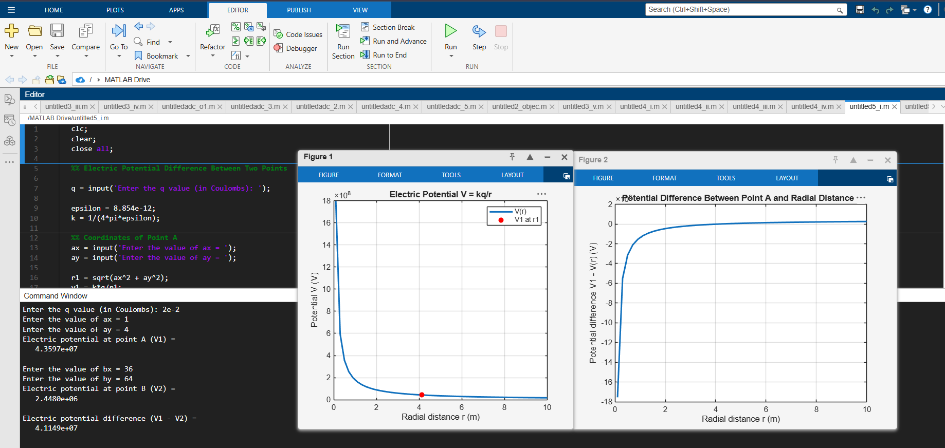
Test case (ii) A positive charge with fixed r₁ = 1 m and r₂ varying.
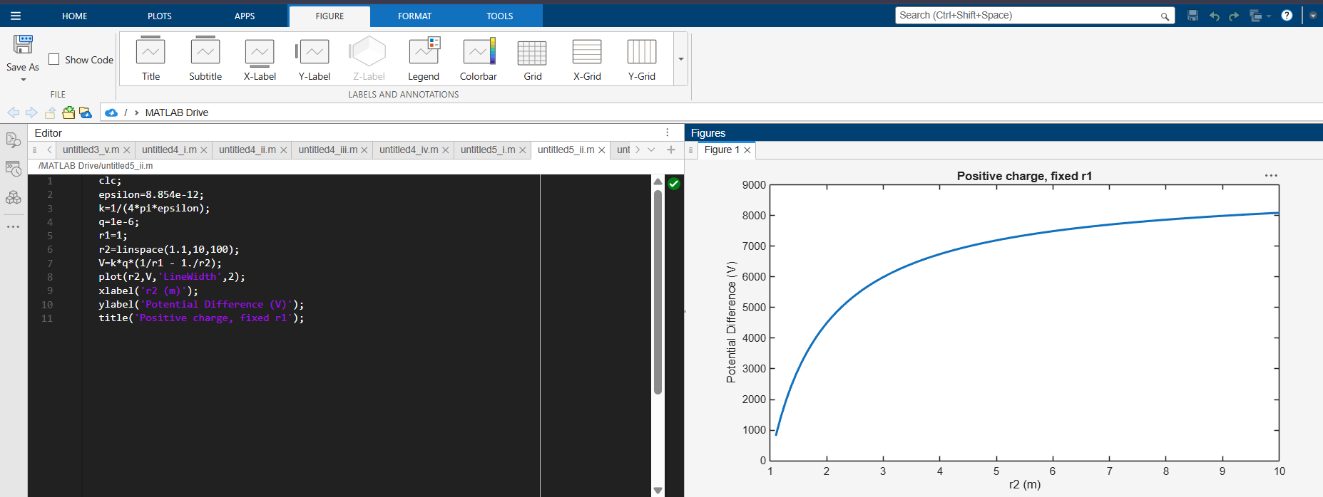

Test case (iii) A negative charge with fixed r₁ and varying r₂:
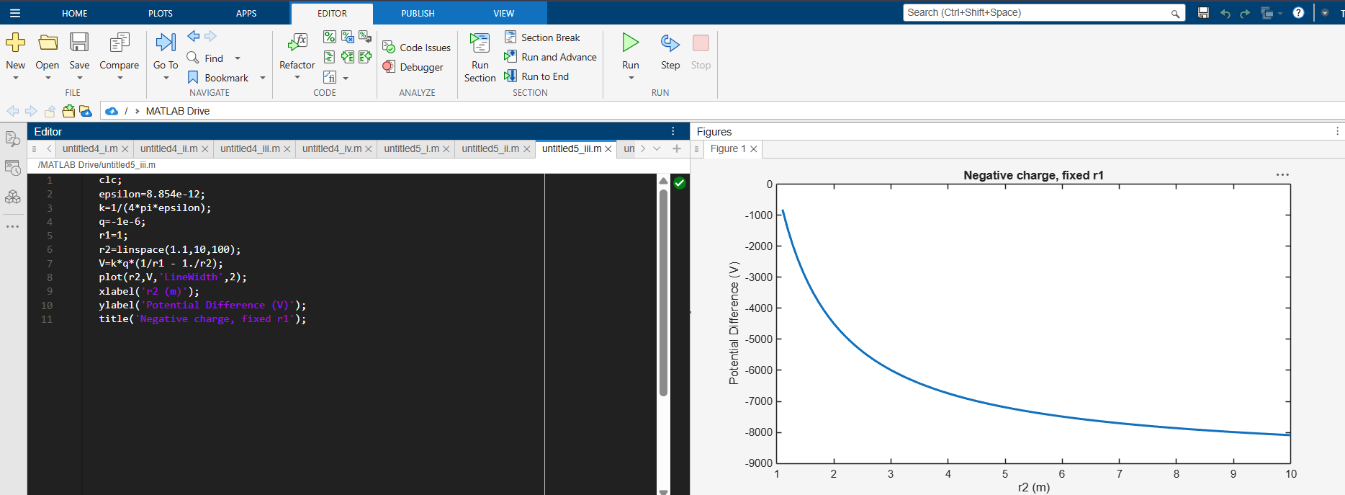
Test case (iv) Both r₁ and r₂ varying with positive charge 3:
